Module 1

Action and Control Flow Blocks

# Action Blocks

## Motor

There are the different modes of the motor blocks. All the motor blocks have the same options for different modes. Here are examples of these modes and what options you have available for each.

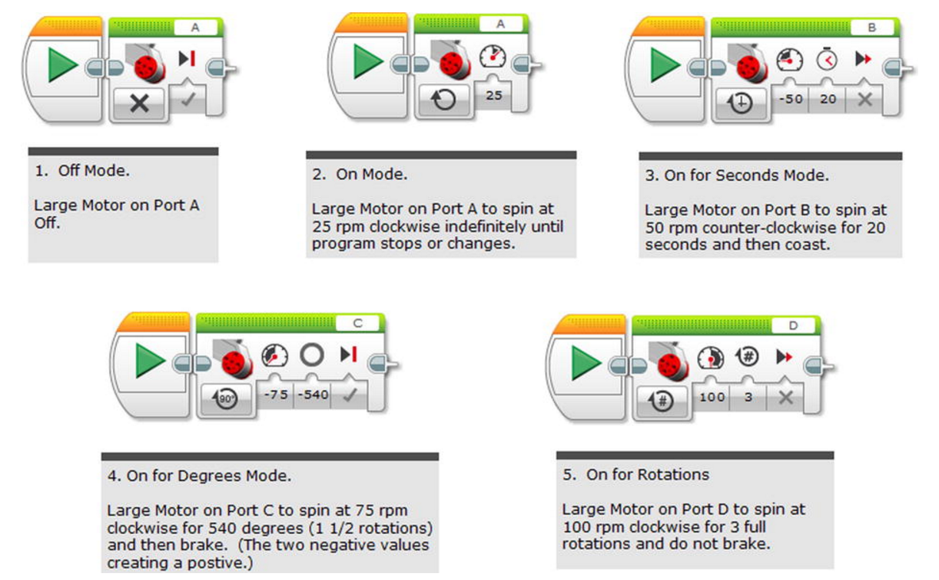

## Display

The Display programming block is capable of creating a graphic to be shown on the screen, and even though the screen is not in colour, it does have good resolution. You will see that the Display block has four modes: Text, Shapes, Image, and Reset Screen that you can see below.

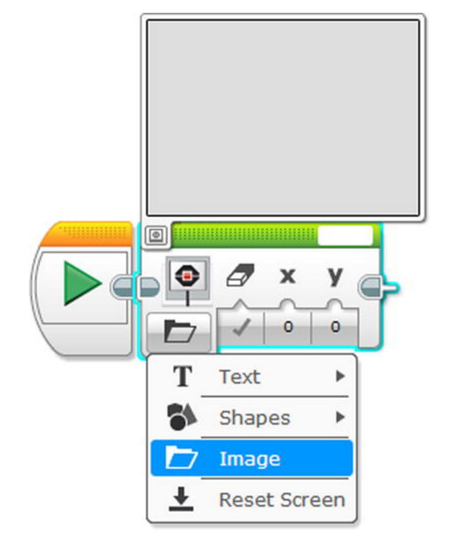

### Text Display

This option allows you to type text in the white box at the top right of the block and display it on the screen. Below are some examples of how to use this.

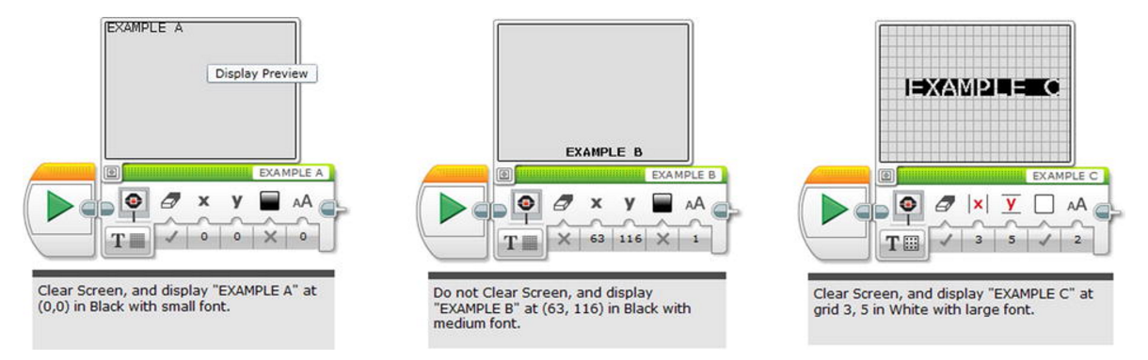

### Shapes

### 

There are 4 types of shapes that can be displayed:

* Line
* Circle
* Rectangle
* Point

### Image

Select an image from the library to display it on the screen.

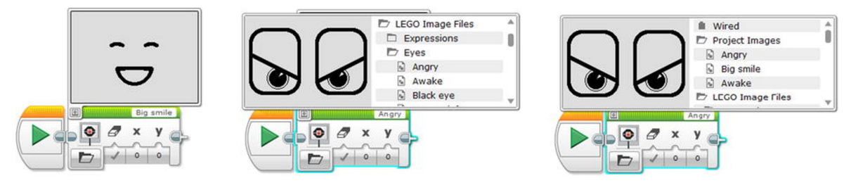

Make your own images using the image editor.

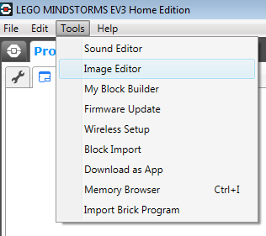

## Sound

This block is designed solely to make some noise, whether it is a note, frequency, pre-programmed, or even user-created. It has four functions: Stop, Play File, Play Tone, and Play Note.

### Play File

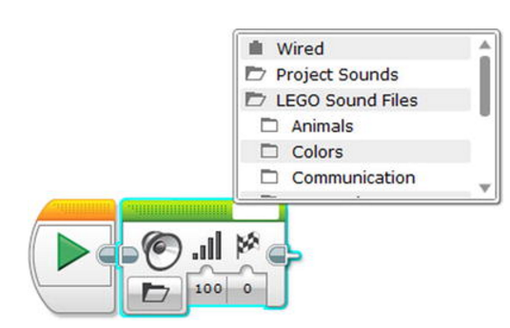

### Play Tone

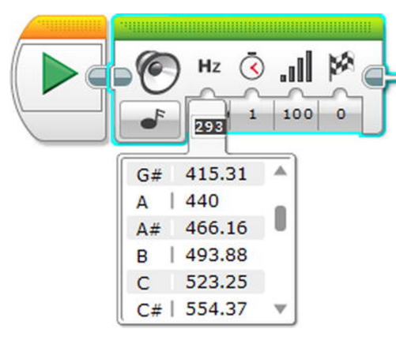

### Play Note

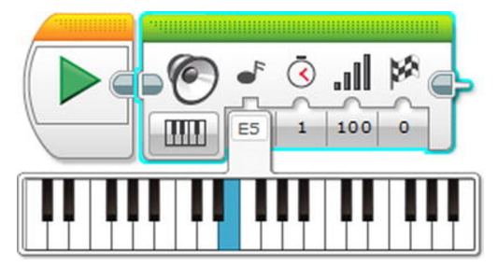

### Sound Editor

This can be used to record your own sounds or convert music files into sound that the EV3 can play. It is limited to 8-10 second recordings.

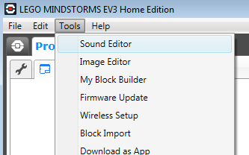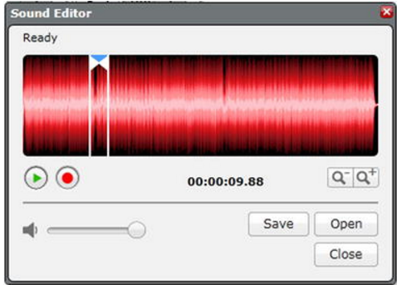

## Brick Status Light

The brick status light allows you to change the colour of the LED behind the buttons. Below are some examples of what you can do with this block.

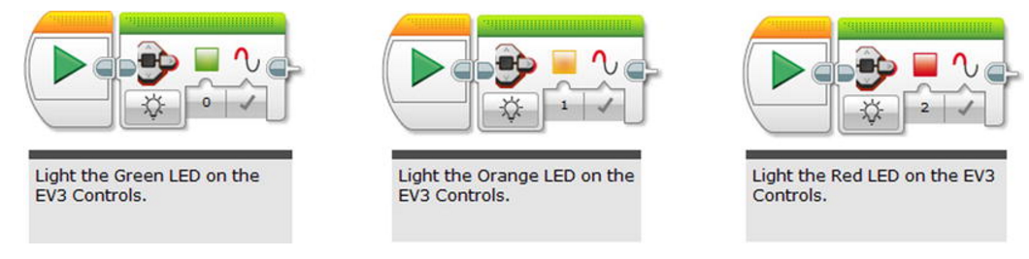

# Control Flow Blocks

It isn’t hard to see why these orange blocks are called Flow, as they do control the flow of programs. If programming was like the flow of water, then the Start programming block sets it in motion. The Wait program will stop the motion like a dam unless something specific is done. The Switch program is made to channel that water into separate areas, if need be. The Loop will insure that the water goes back to its source, and starts again. Loop Interrupt is made to stop that process.

## Wait

The Wait or “Wait For” programming block is precisely what its name implies. This brick instructs the program to wait, and you can even shift its mode so it knows exactly what it is waiting for. Each mode is related to a sensor and all the modes are shown below.

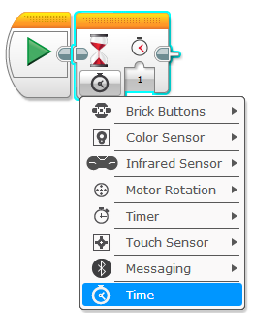

## Loop

Occasionally, you will want to set up a program so that it does the same thing over and over again. Rather than put several similar programming blocks together, this can be accomplished with the Loop programming block. Not only can you use the Loop to do something over again, but you can program to stop at a certain response.

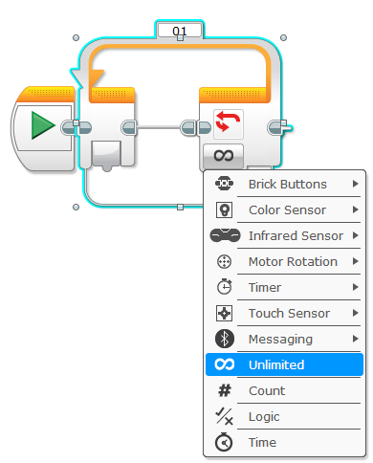

## Switch

The Switch is essentially a big if/then statement in your program. When you are using a Switch in your program, you are saying: “If this happens, then do this. If this doesn’t happen, do that”. The Switch comes in two forms: Measure and Compare. Measure allows for creating several cases, so it isn’t just two options, but several. All you need to do is click on the “+” button. You will also need to click a default setting which is what you tell the program to do when it can’t figure out what to do next. As for Compare, this is one measurement or the other.

You might notice that you can view the Switch form in the regular mode or tabbed mode. Tabbed mode allows a smaller view where you can click on the options to see what you can do.

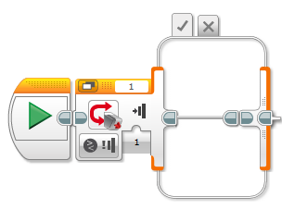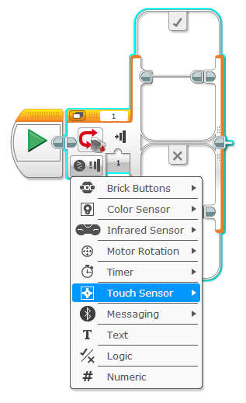

## Loop Interrupt

The last programming block is the Loop Interrupt, and it is really made for special situations. As you make quite a lot of programs, you might want one where the Loop only needs to work but not completely, as some programmers would call a “break” statement.

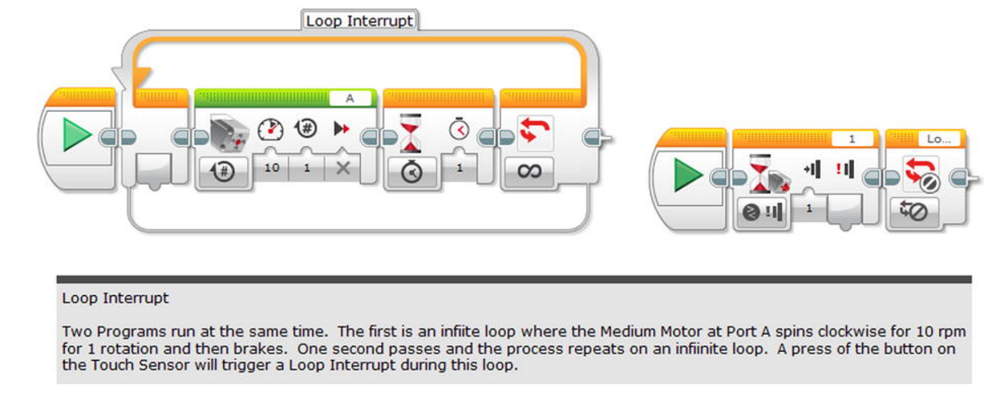

# Activity – Guard the Door

Your robot needs to guard the front door to your room. See if you can make it march back and forth in front of the door and sound an alarm when someone walks in front of the robot.

### Scoring

Each block is worth points to your score. The lowest score wins.

(Blocks used to complete the Bonus Challenges are not counted in the score)

* Play Block – 50 points
* Action Block – 10 points
* Sound Block – 5 points
* Loop Block – 5 points
* Switch Block – 2 points

For programs with the same score, the winner will be decided on the use of comment tabs in the program to document the flow of the program.

## Bonus Challenges

* Add your own voice to the alarm. You are going to need a microphone to complete this challenge.
* Use the brick status lights to indicate a warning along with the sound.
* Display an image on the screen to assist in the warning.